**Arithmetic Operators**

An **operator** is a symbol that operates on a value to perform specific mathematical or logical computations. They form the foundation of any programming language. In C++, we have built-in operators to provide the required functionality.

An operator operates the **operands**. For example,

int c = a + b;

Here, ‘+’ is the addition operator. ‘a’ and ‘b’ are the operands that are being ‘added’.

**Operators in C++ can be classified into 6 types:**

1. **Arithmetic Operators**
2. Relational Operators
3. Logical Operators
4. Bitwise Operators
5. Assignment Operators
6. Ternary or Conditional Operators

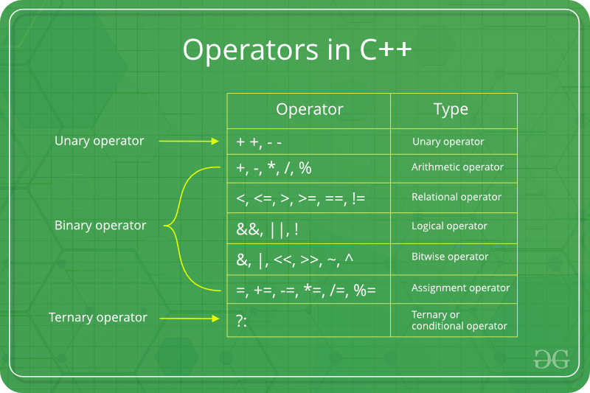

**Arithmetic Operators**

These operators are used to perform arithmetic or mathematical operations on the operands. For example, ‘+’ is used for addition, ‘-‘ is used for subtraction ‘*’ is used for multiplication, etc.

**Arithmetic Operators can be classified into 2 Types:**

**A) Unary Operators:**These operators operate or work with a single operand. For example: Increment(++) and Decrement(–) Operators.

| **Name** | **Symbol** | **Description** | **Example** |
| --- | --- | --- | --- |
| Increment Operator | ++ | Increases the integer value of the variable by one | int a = 5;  a++; // returns 6 |
| Decrement Operator | — | Decreases the integer value of the variable by one | int a = 5;  a–; // returns 4 |

**Example:**

C++

// CPP Program to demonstrate the increment

// and decrement operators

#include <iostream>

using namespace std;

int main()

{

int a = 10;

cout << "a++ is " << a++ << endl;

cout << "++a is " << ++a << endl;

int b = 15;

cout << "b-- is " << b-- << endl;

cout << "--b is " << --b << endl;

return 0;

}

**Output**

a++ is 10

++a is 12

b-- is 15

--b is 13

***Note:******++a****and****a++****, both are increment operators, however, both are slightly different.*

*In****++a****, the value of the variable is incremented first and then It is used in the program. In****a++****, the value of the variable is assigned first and then It is incremented. Similarly happens for the decrement operator.*

**B) Binary Operators:**These operators operate or work with two operands. For example: Addition(+), Subtraction(-), etc.

| **Name** | **Symbol** | **Description** | **Example** |
| --- | --- | --- | --- |
| Addition | + | Adds two operands | int a = 3, b = 6;  int c = a+b; // c = 9 |
| Subtraction | – | Subtracts second operand from the first | int a = 9, b = 6;  int c = a-b; // c = 3 |
| Multiplication | * | Multiplies two operands | int a = 3, b = 6;int c = a*b; // c = 18 |
| Division | / | Divides first operand by the second operand | int a = 12, b = 6;    int c = a/b; // c = 2 |
| Modulo Operation | % | Returns the remainder an integer division | int a = 8, b = 6;  int c = a%b; // c = 2 |

***Note:****The Modulo operator(%) operator should only be used with integers.*

**Example:**

C++

// CPP Program to demonstrate the Binary Operators

#include <iostream>

using namespace std;

int main()

{

int a = 8, b = 3;

// Addition operator

cout << "a + b = " << (a + b) << endl;

// Subtraction operator

cout << "a - b = " << (a - b) << endl;

// Multiplication operator

cout << "a * b = " << (a * b) << endl;

// Division operator

cout << "a / b = " << (a / b) << endl;

// Modulo operator

cout << "a % b = " << (a % b) << endl;

return 0;

}

**Output**

a + b = 11

a - b = 5

a * b = 24

a / b = 2

a % b = 2